# INDRODUCTION :

# overview

## I Design a social media using in this canva .

## That was very easy to use . Anyone to use this canva easier

# Purpose

## My project is creating a social media

## I Create a social media using in this canva

# 

# 2. Problems Definition & Social Media Creating

## 2.1 Empathy map

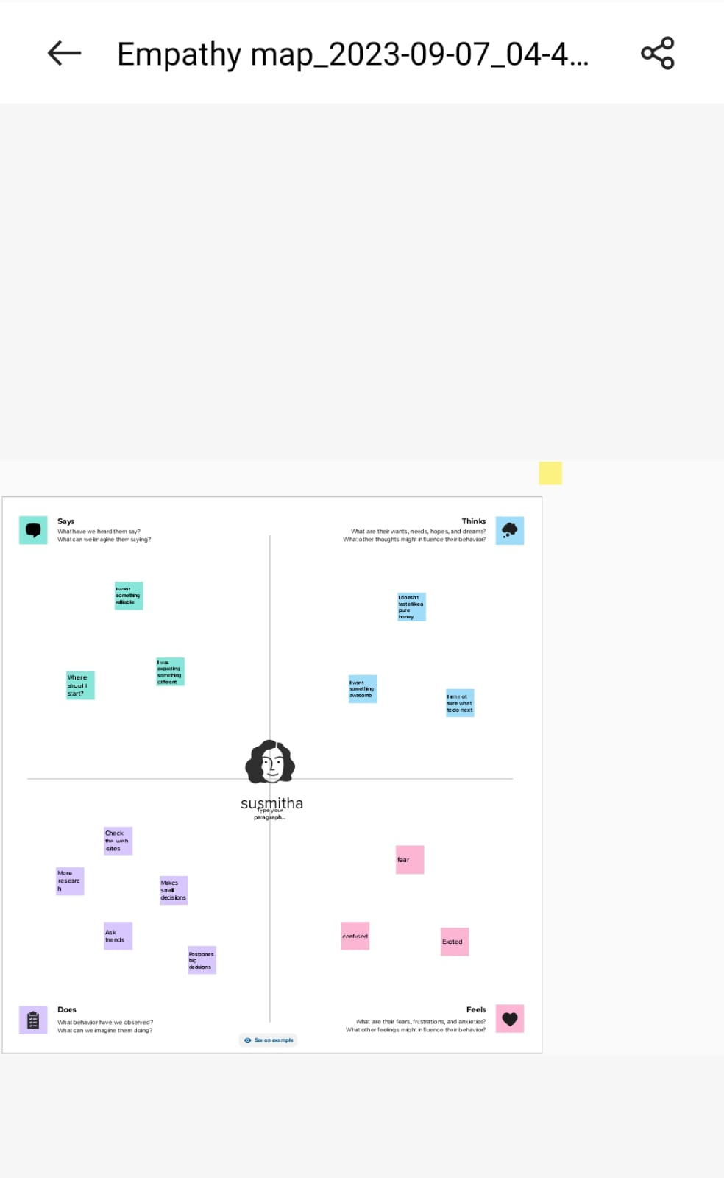

# 2.2 Brain strom and idea prioritization

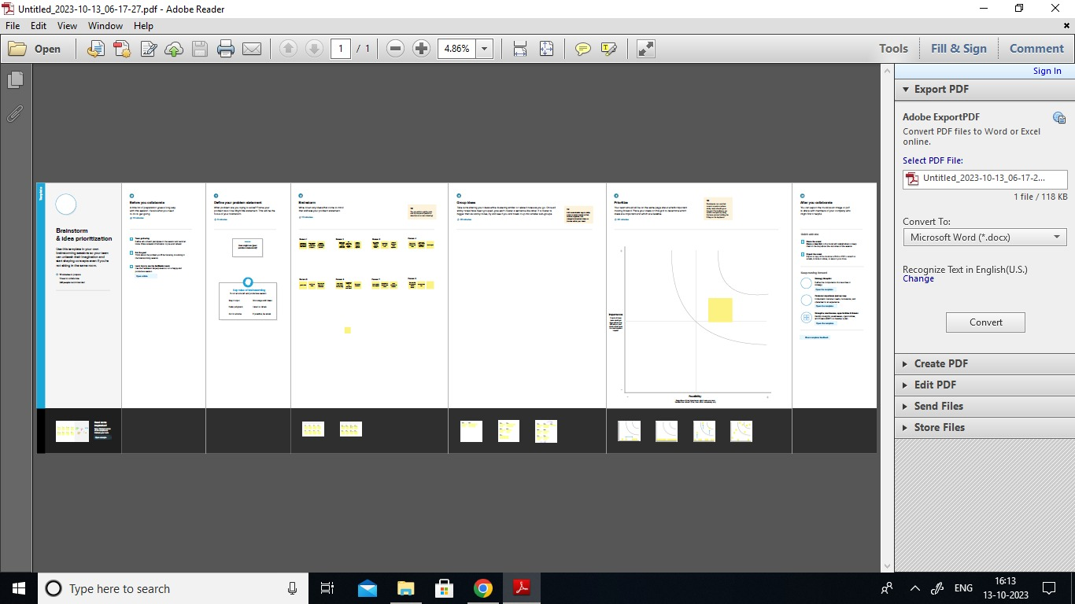

# 3. Result



## 4 ADVANDAGES AND DISADVANDAGES

## Easy to using this canva

## Freshers can easy to design anything inthis canva

## In this canva has many templates

## Canva was very useful to everyone

# 5. CONCLUSION

## I easily finish my project Social Media . canva is the most useful and best app for the freshers . Beacause , that has has many templates that was easy to use